How to create azure synapse analytics

1. Create resource group
2. Storage account
3. And a container
4. Then go to azure synapse analytics

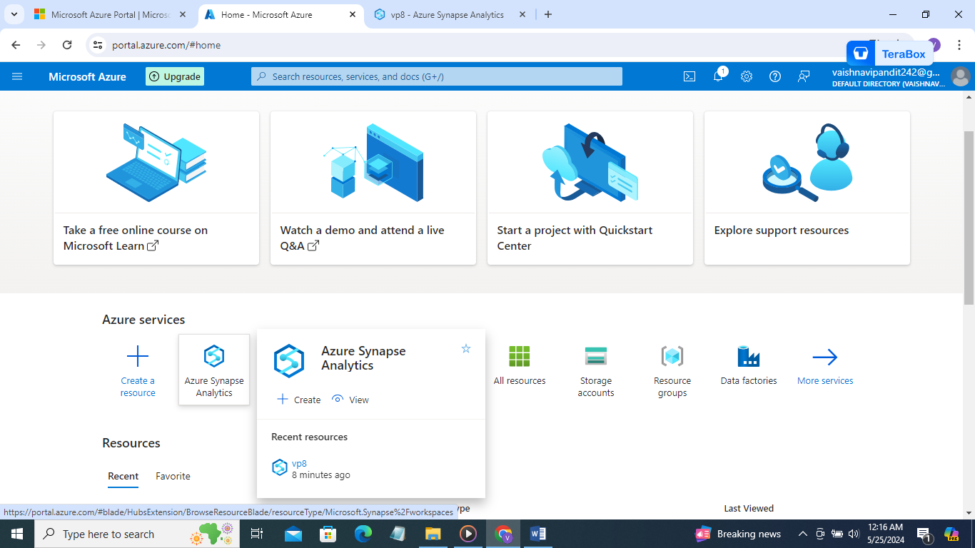

1. Then go create synapse workspace
2. Add resource group storage account and the container and create

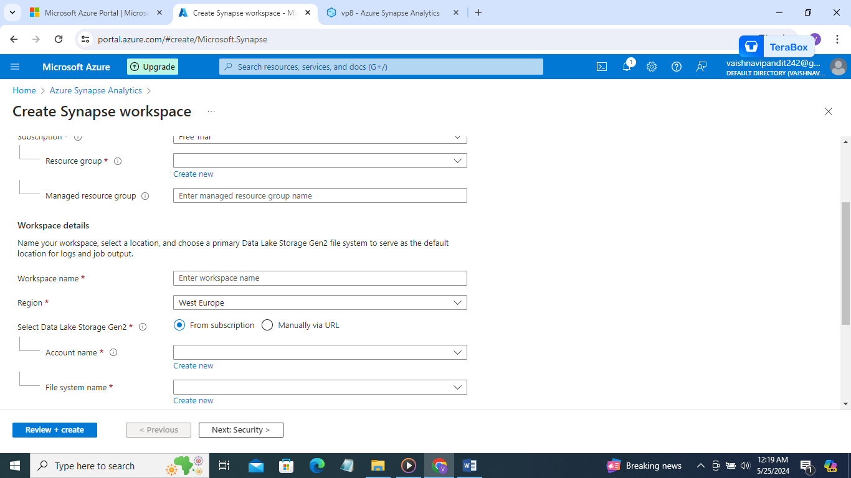

1. Then go to workspace and click on the link workspace url

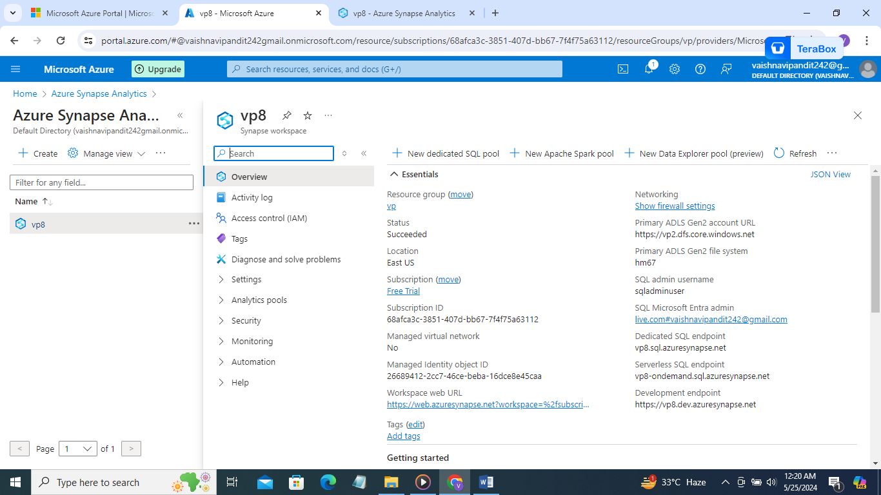

1. Now go to author there you will get default serverless sql pool

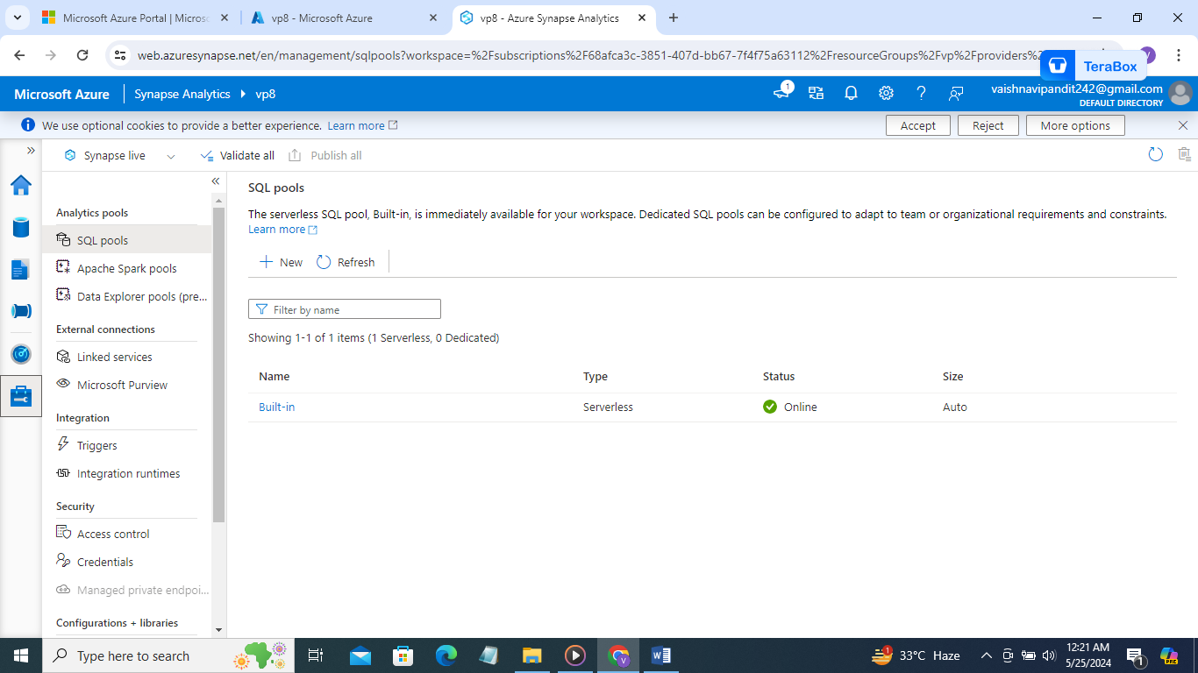

1. Then go to apache spark pools

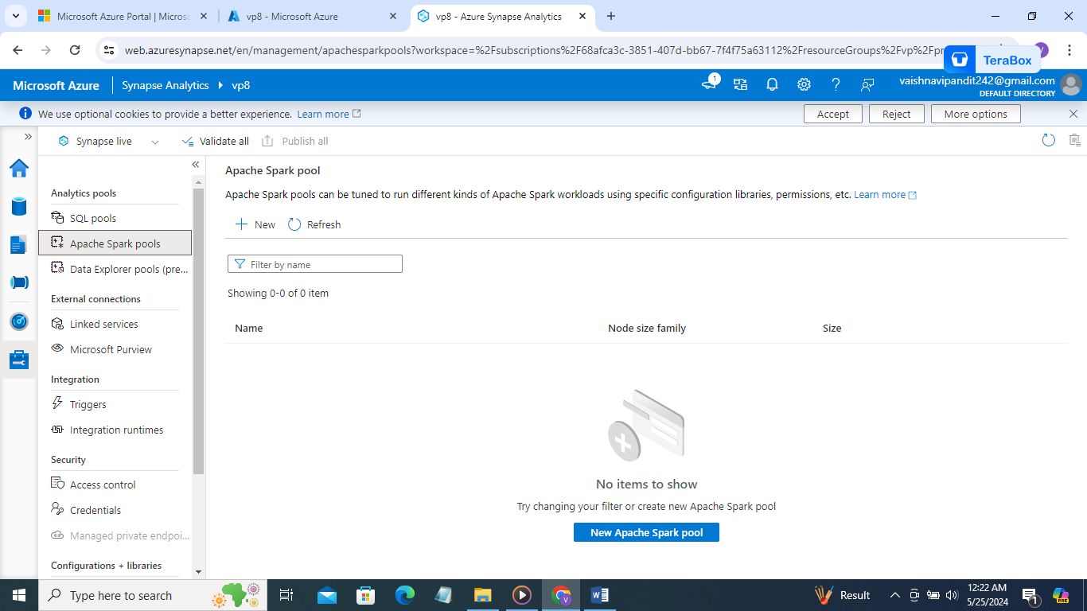

1. New apache spark pool

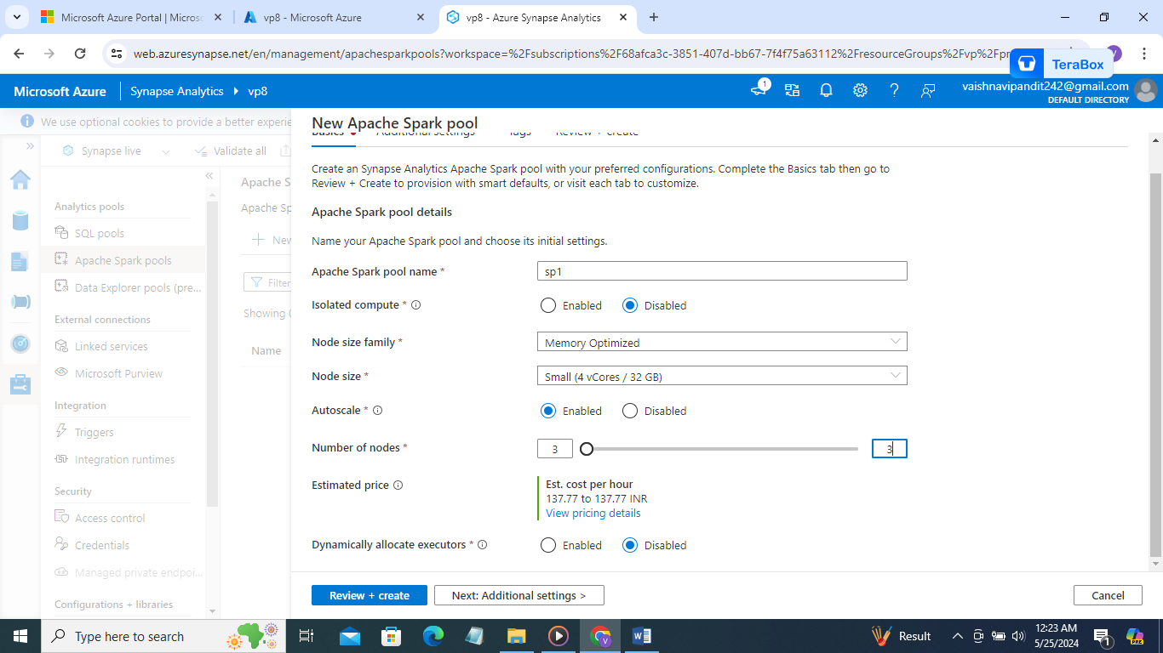

1. You can go to data ->linked and there can see linked storage account container

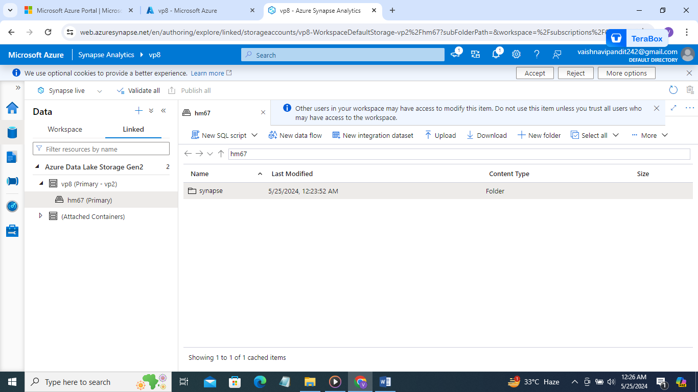

1. Create folder and upload the csv file there

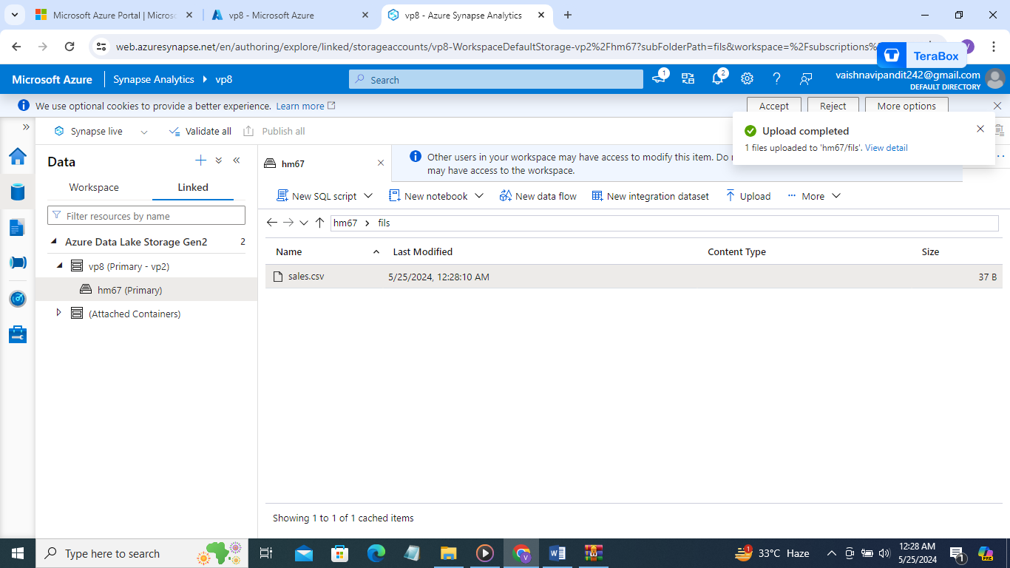

1. In data we get info about the azure data lake storage in linked
2. Then in devlop we can add sql scripts, notebooks etc

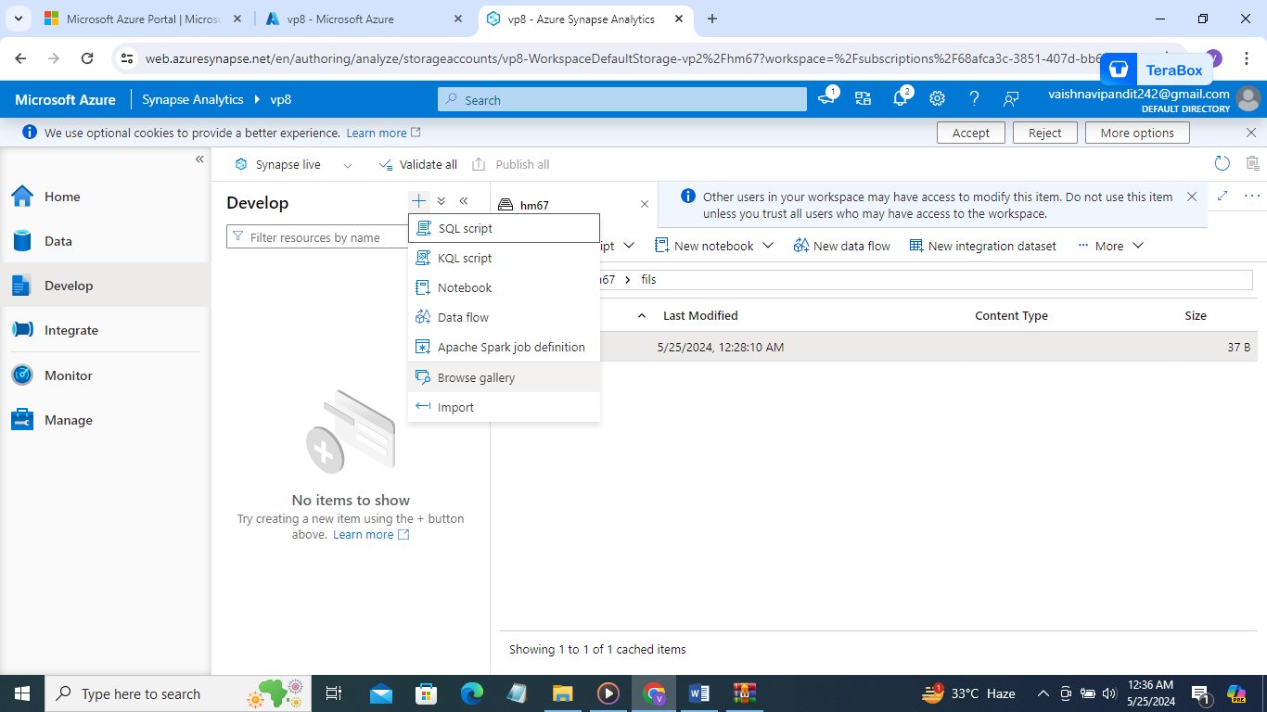

1. In integrate we can add multiple pipelines and all like azure data factories

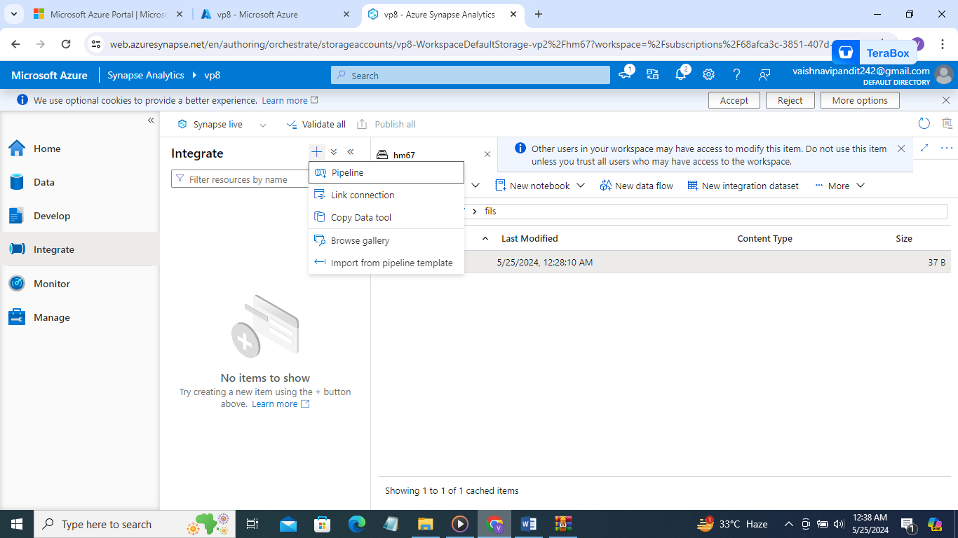

1. In manage we have sql servers and linked services triggers etc

